Supplementary File

Supplementary Figure S1. Least square means for the energy efficiency-related traits (A) milk urea nitrogen in ml/l (MUN), (B) fat to protein ratio (FPR), (C) saturated fatty acids in g/100g milk (SFA), (D) unsaturated fatty acids in g/100g milk (UFA), (E) monounsaturated fatty acids in g/100g milk (MUFA), (F) polyunsaturated fatty acids in g/100g milk (PUFA), (G) short-chain fatty acids in g/100g milk (SCFA), (H) medium-chain fatty acids in g/100g milk (MCFA), (I) long-chain fatty acids in g/100g milk (LCFA), (J) body condition score (BCS), (K) back fat thickness in cm (BFT), (L) feeding time in min/day and (M) rumination time in min/day of the high input (HI) group (▲) and the low input (LI) group (■) for the 3 estimated breeding value classes (EBV_low = blue, EBV_int = orange, EBV_high = green) by days in milk (DIM).

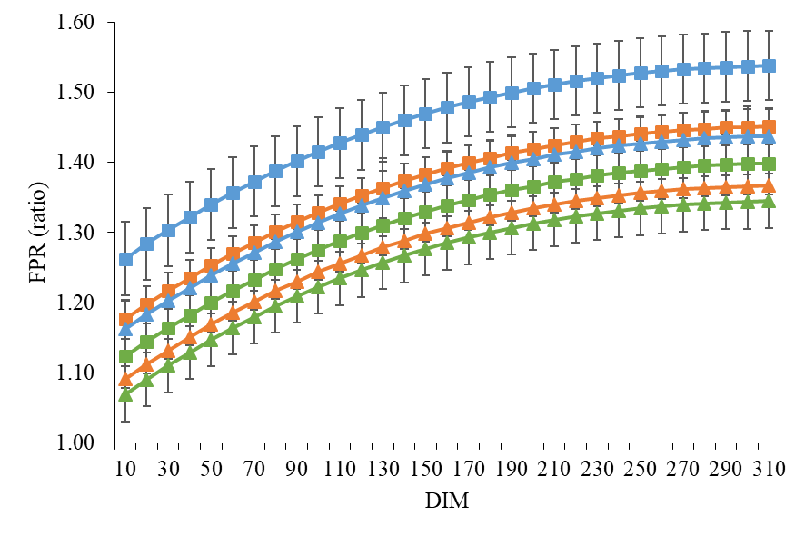
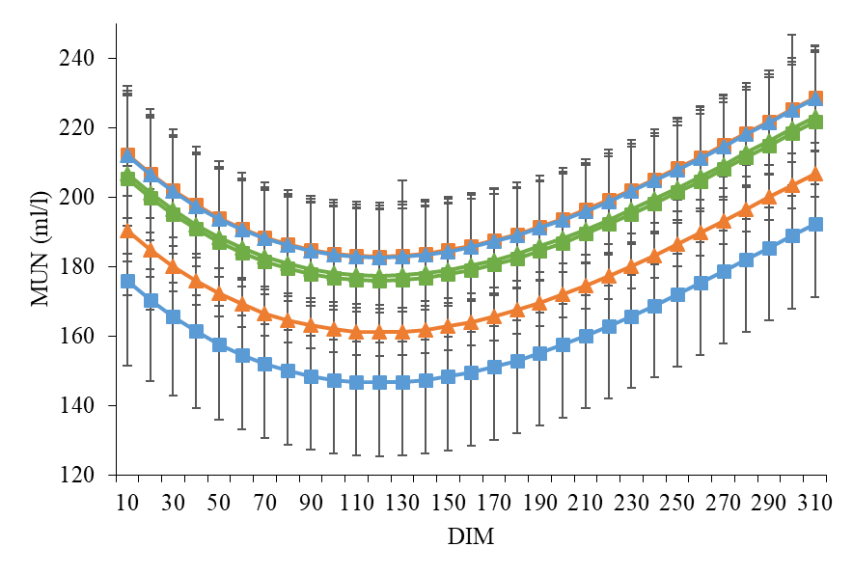
B
A
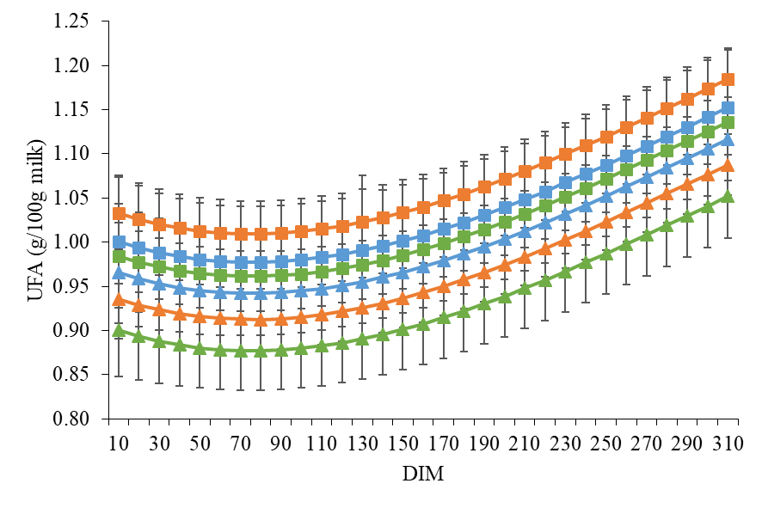
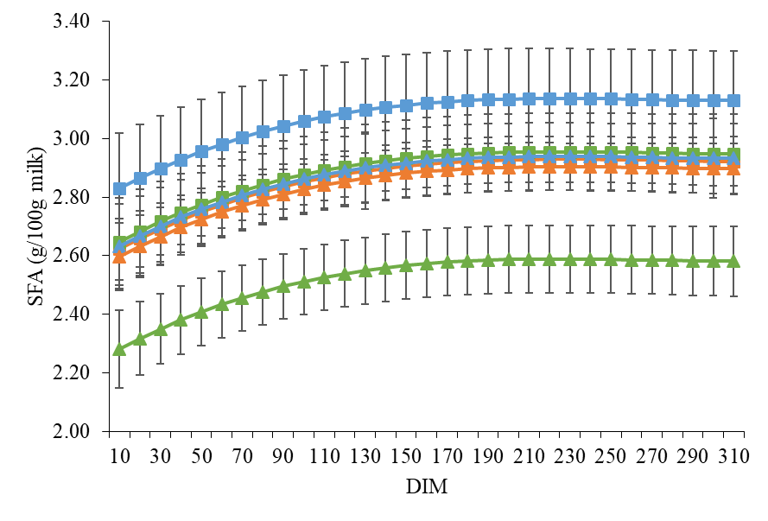
D
C
E
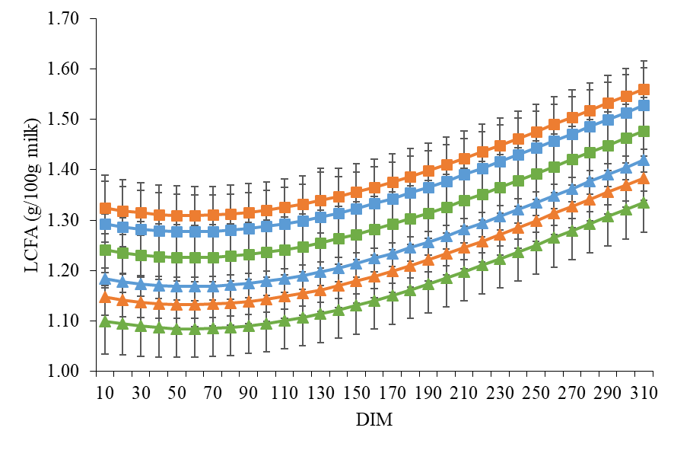
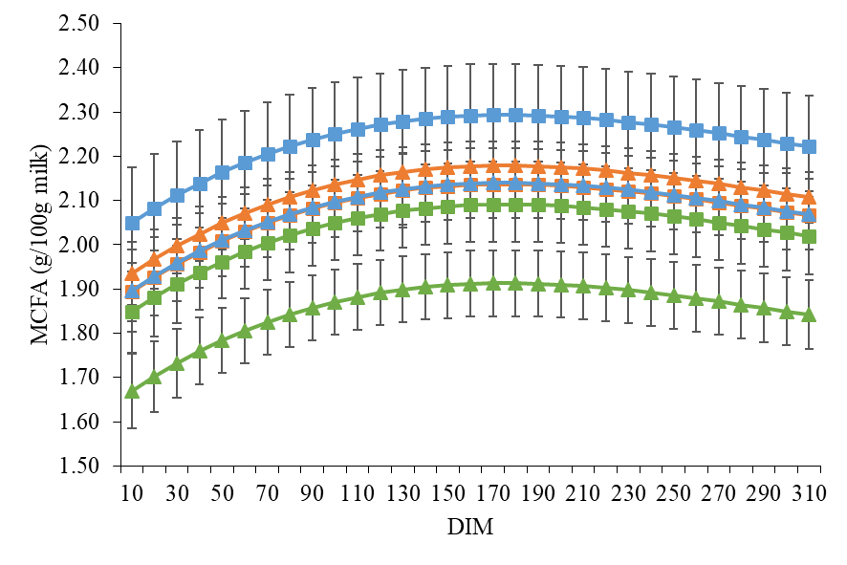
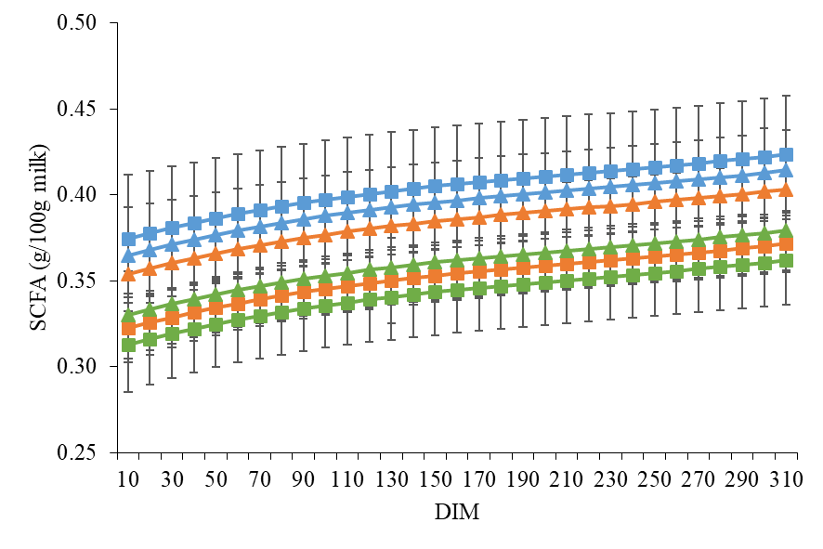
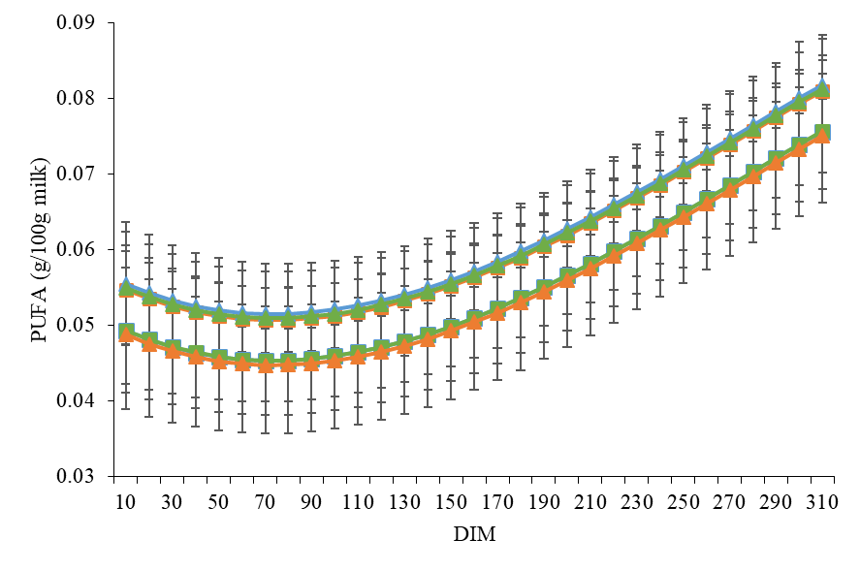
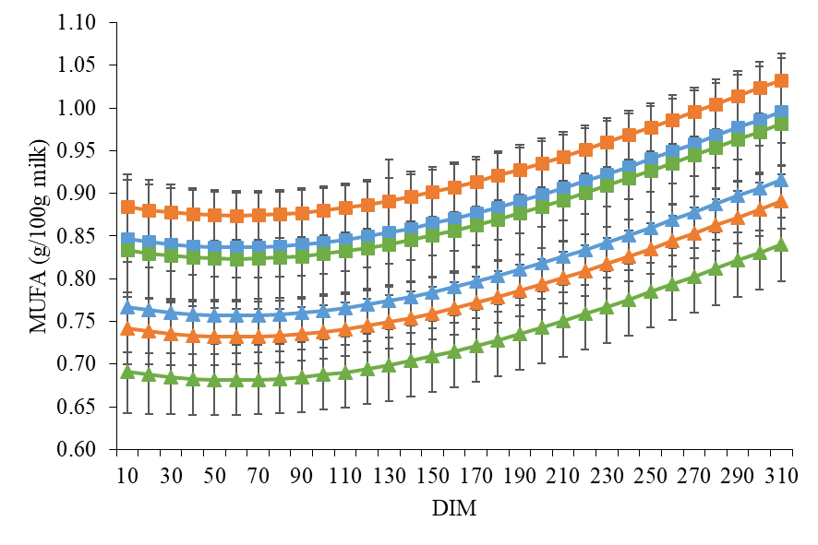
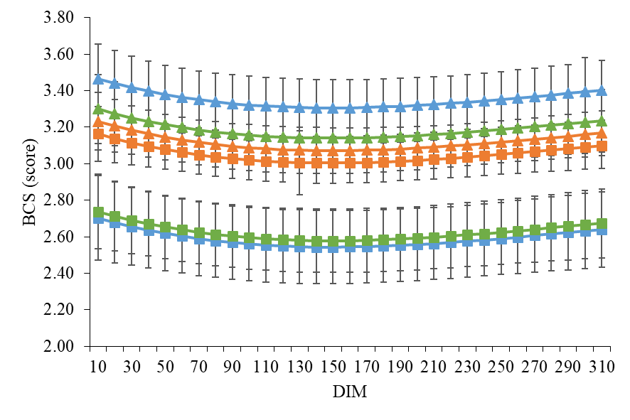
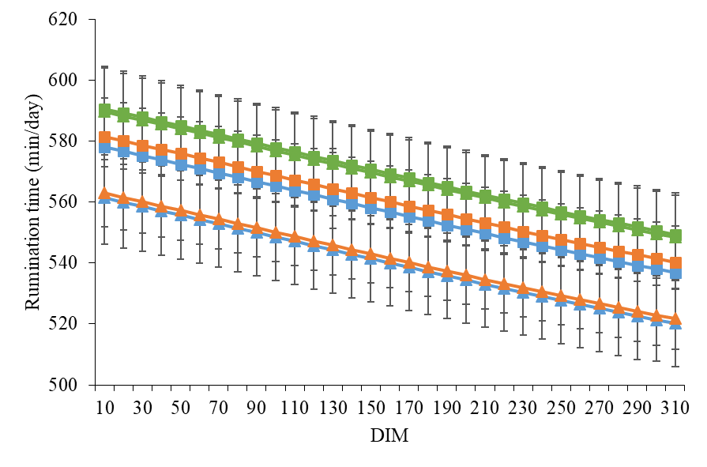
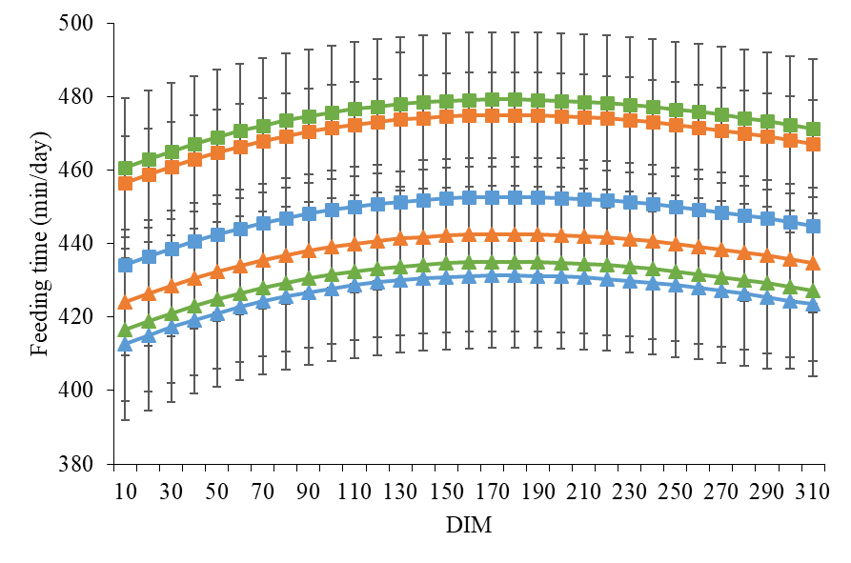
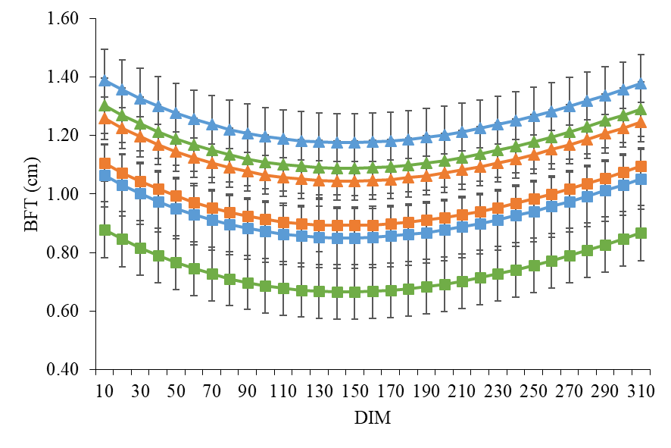
I
H
G
F
E
M
L
K
J

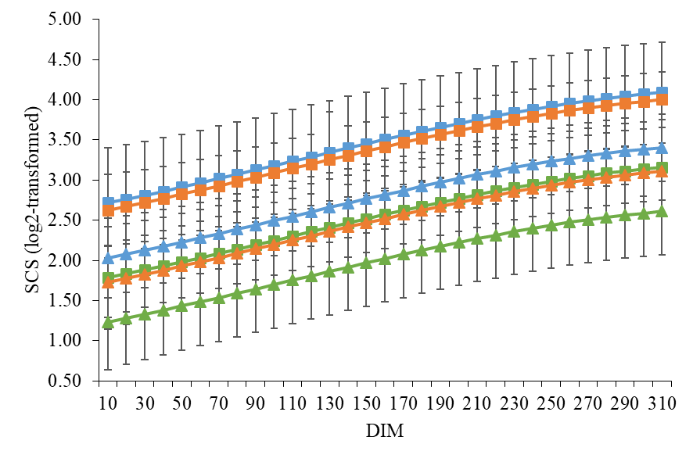
Supplementary Figure S2. Least square means for somatic cell score (SCS) of the high input (HI) group (▲) and the low input (LI) group (■) for the 3 estimated breeding value classes (EBV_low = blue, EBV_int = orange, EBV_high = green) by days in milk (DIM).

